**PKPL**

**Final Project Report**



**DISUSUN OLEH:**

Jesica Ananda A. 11320013

Sophia Tambunan 11320048

**INSTITUT TEKNOLOGI DEL**

**FAKULTAS VOKASI**

**Pengujian Aplikasi Alison Menggunakan Cucumber**

1. **Fungsi Login**
   1. Test Frame

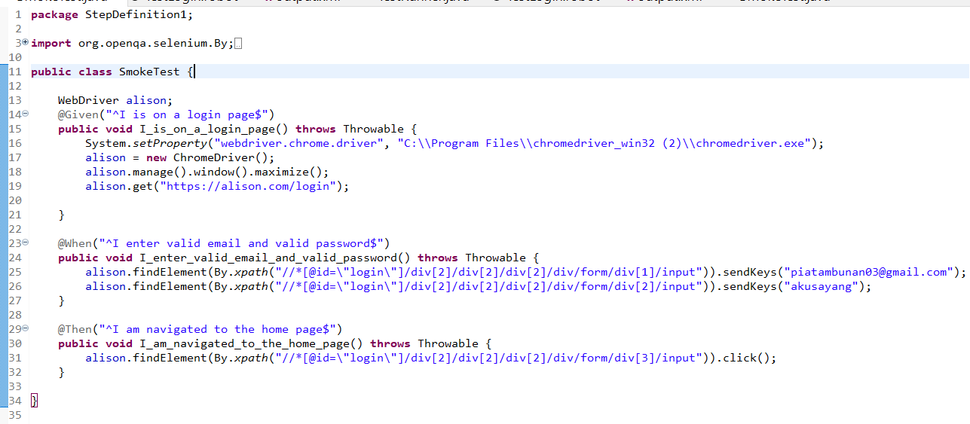

* 1. Scenario

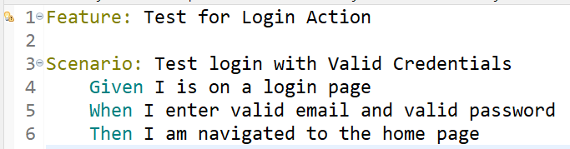

* 1. Test Runner

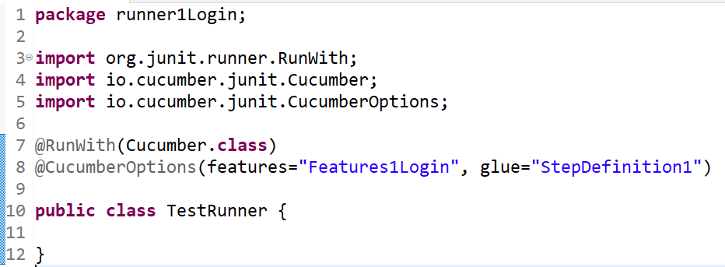

* 1. Console

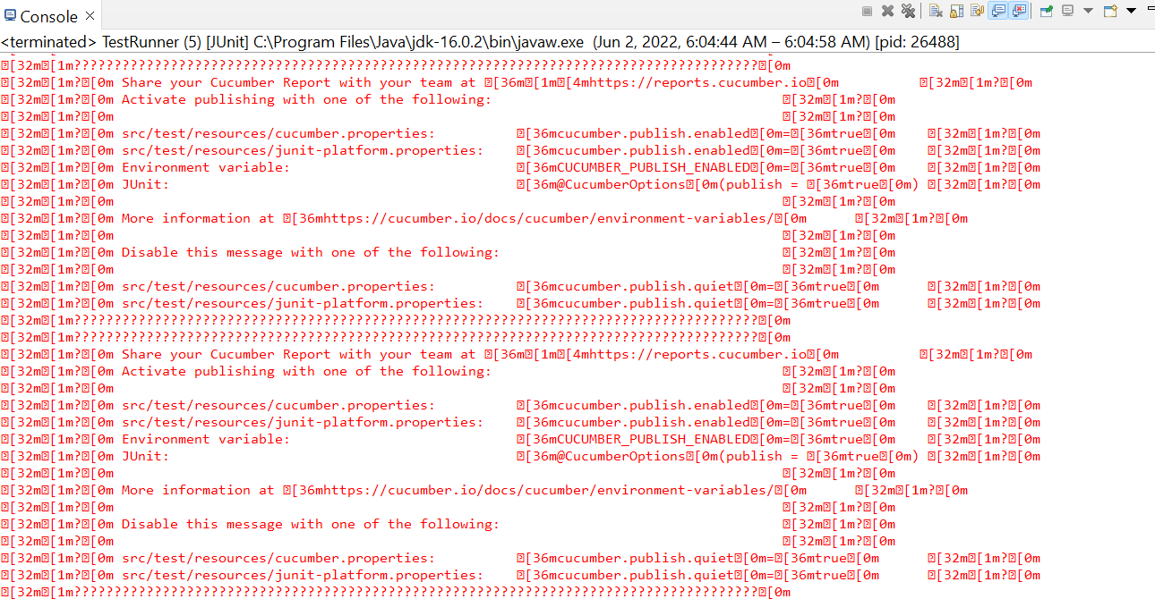

* 1. Browser

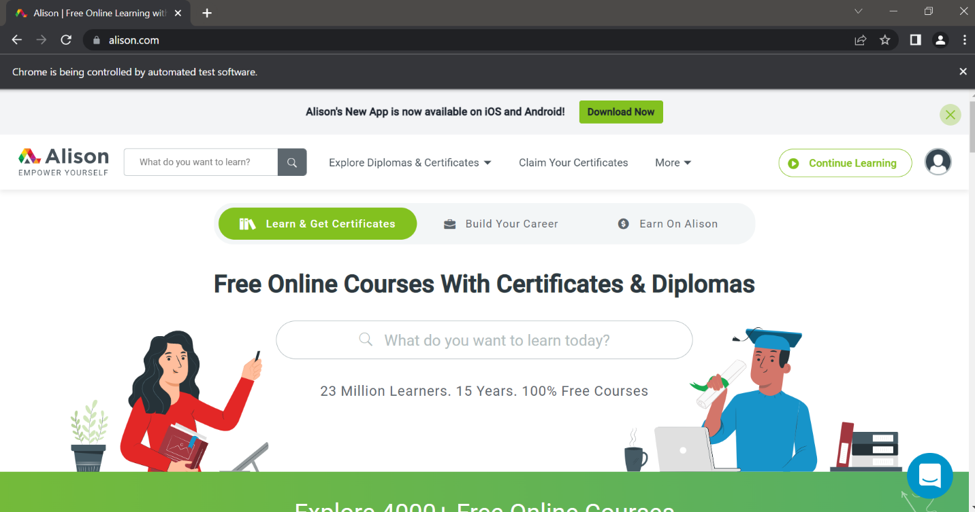

1. **Fungsi Search** 
   1. Test Frame

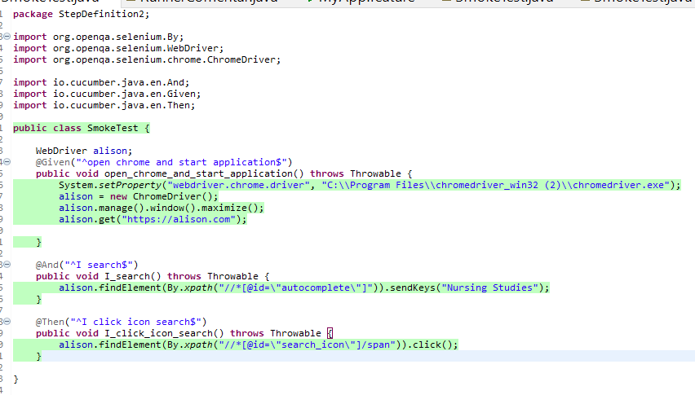

* 1. Scenario

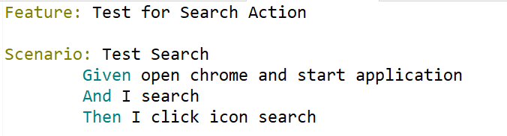

* 1. Test Runner

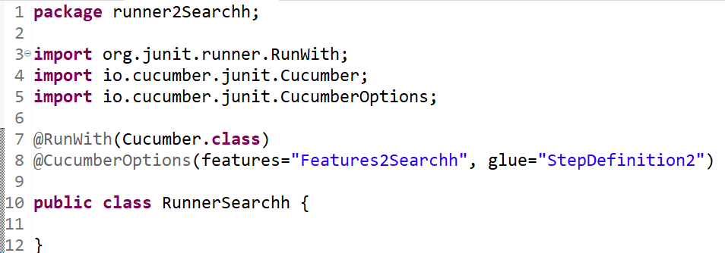

* 1. Console

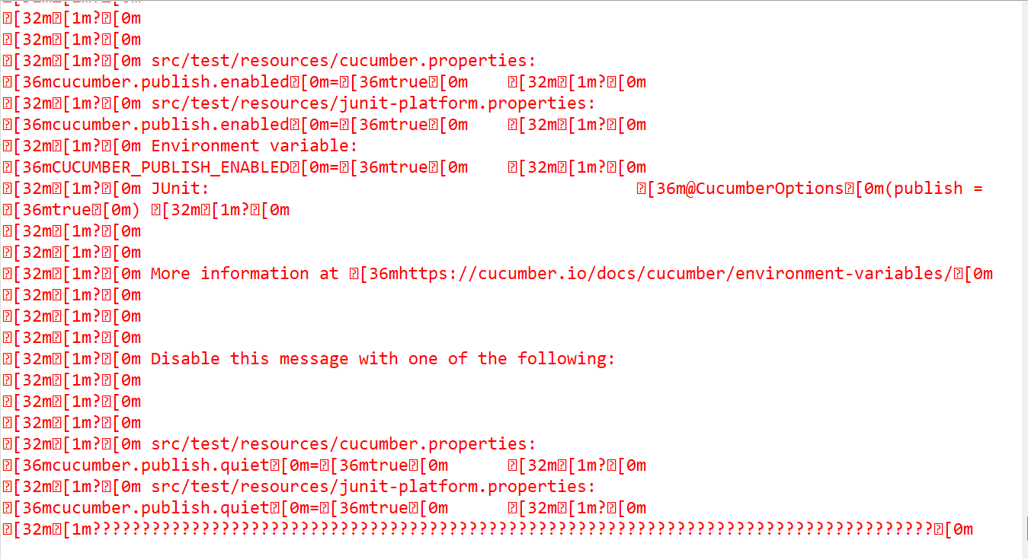

* 1. Browser

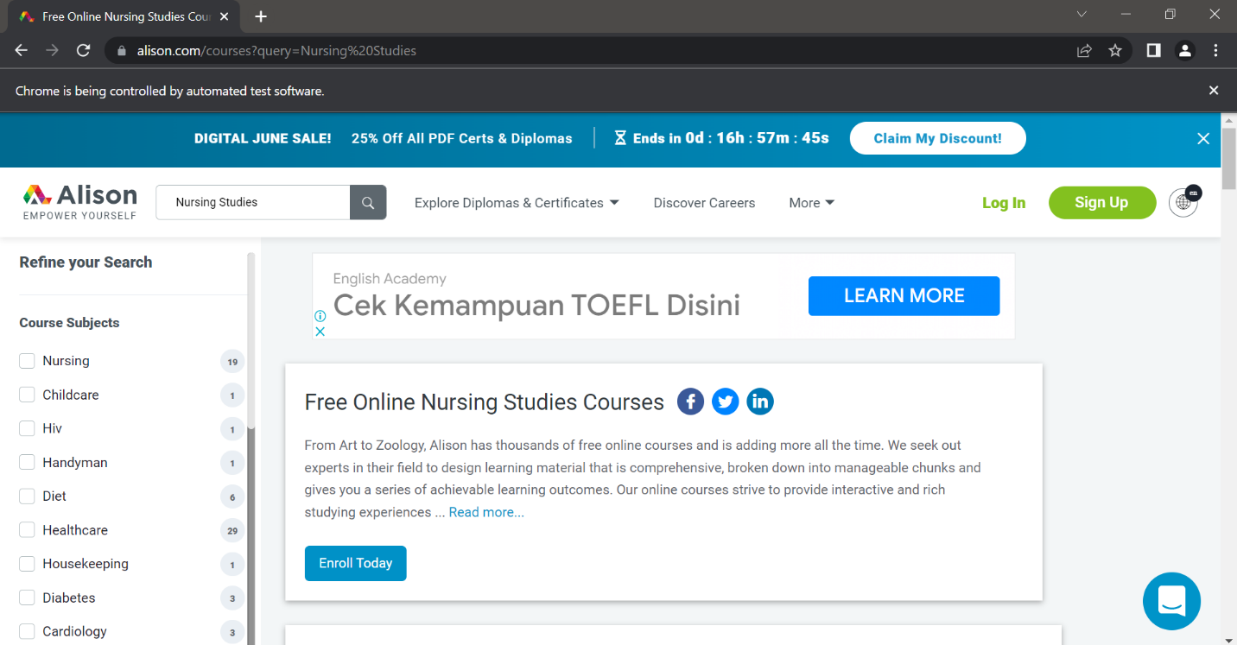

1. **Fungsi Search**
   1. Test Frame

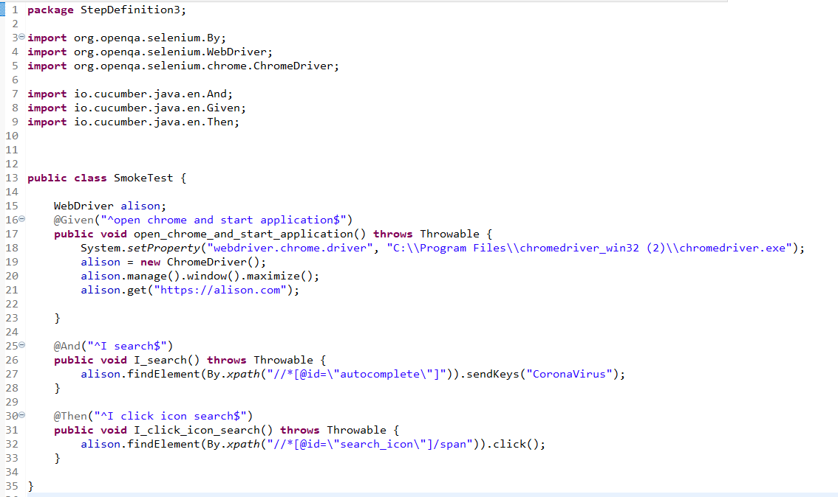

* 1. Scenario

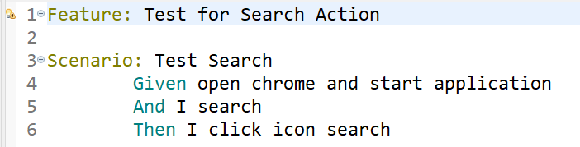

* 1. Test Runner

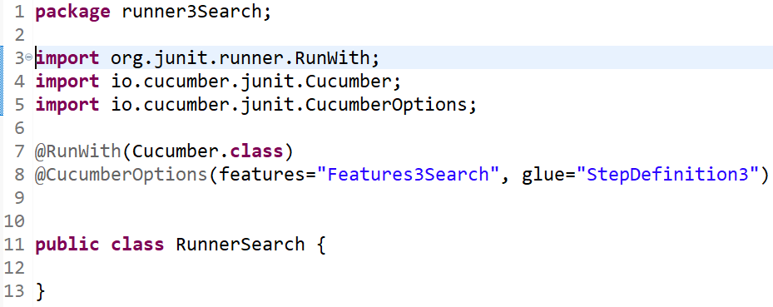

* 1. Console



* 1. Browser

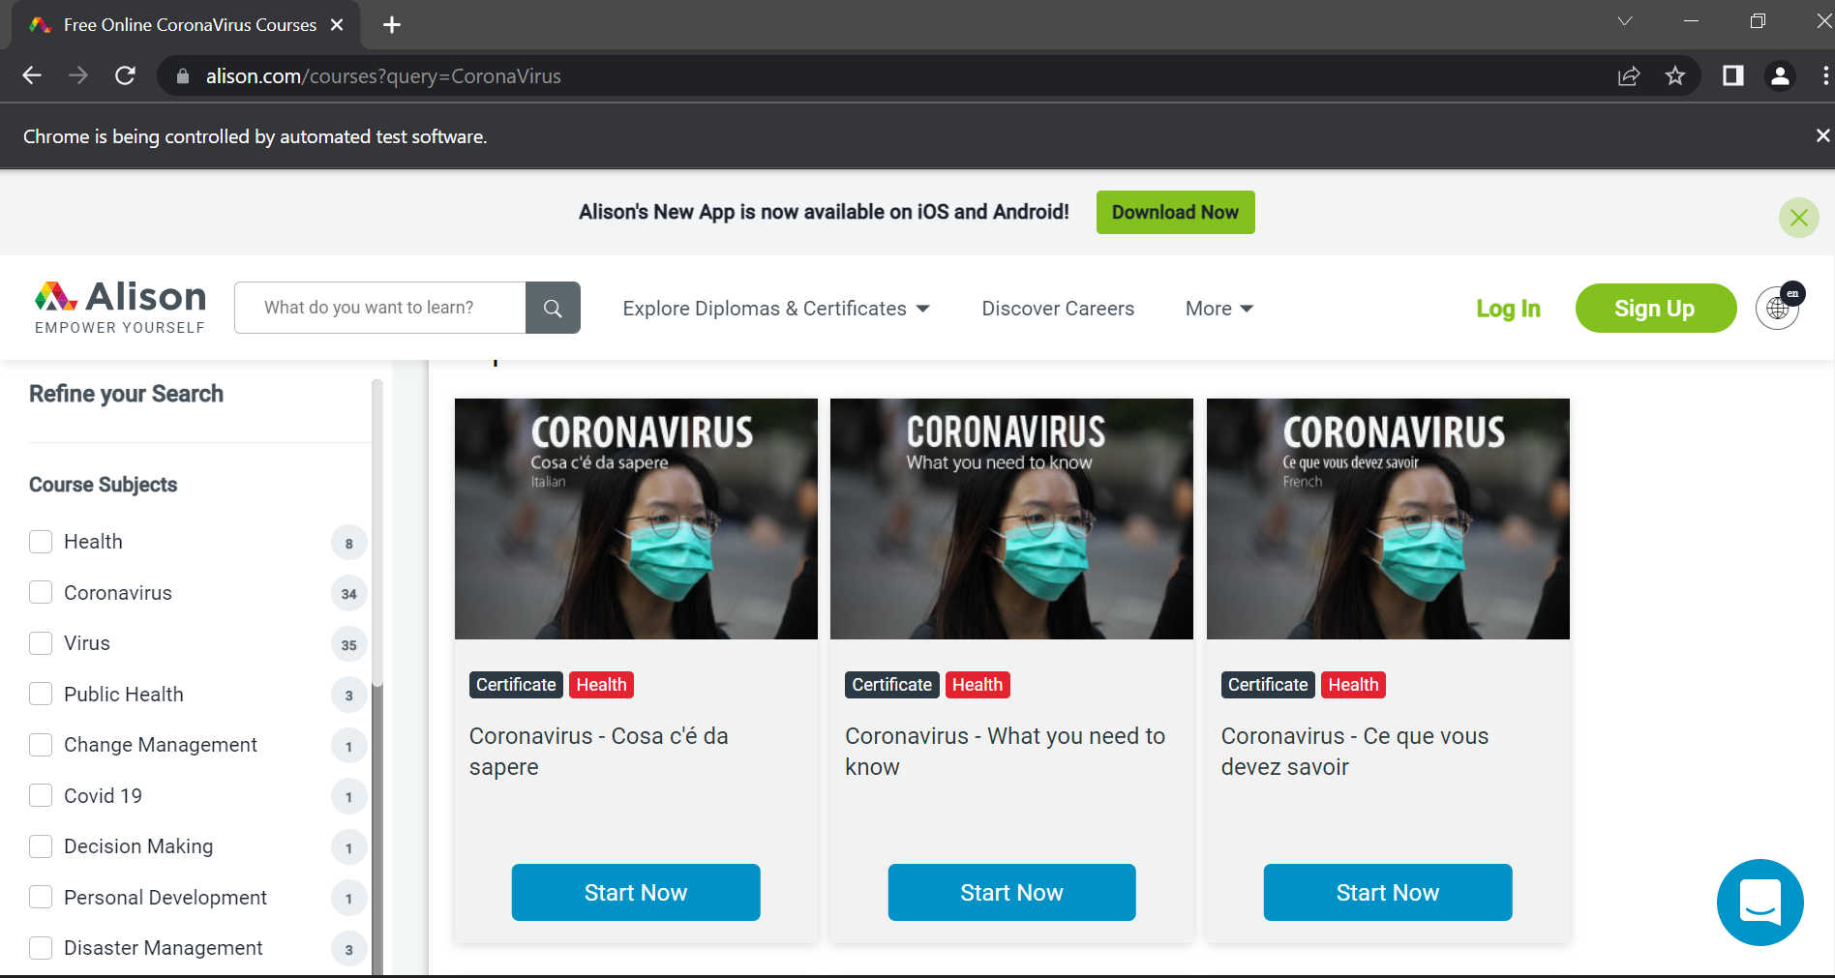

1. **Fungsi Register**
   1. Test Frame

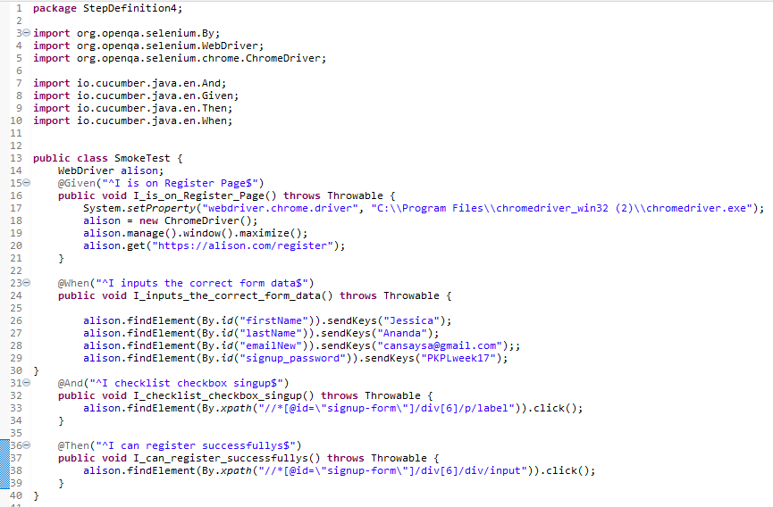

* 1. Scenario

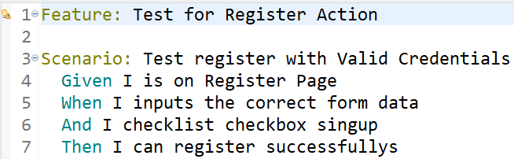

* 1. Test Runner

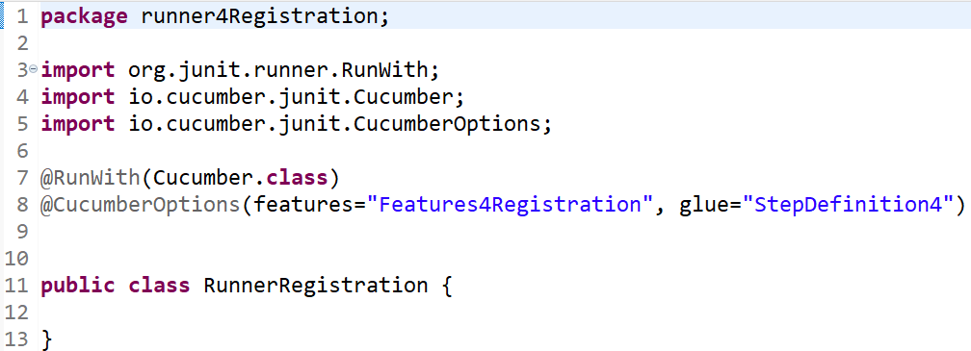

* 1. Console

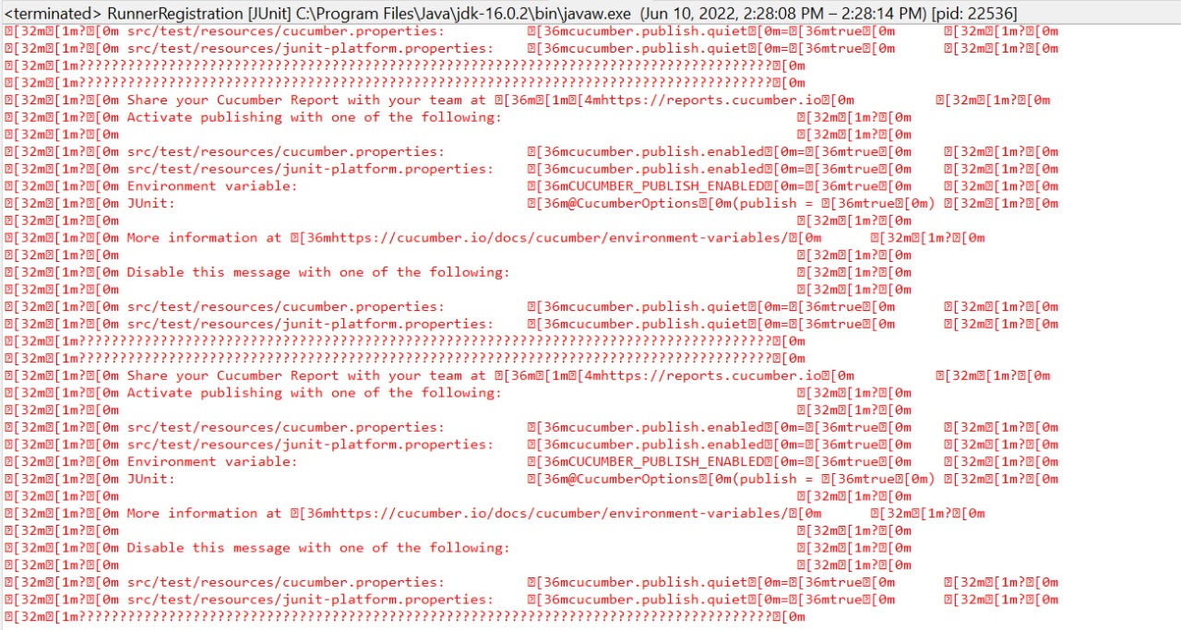

* 1. Browser

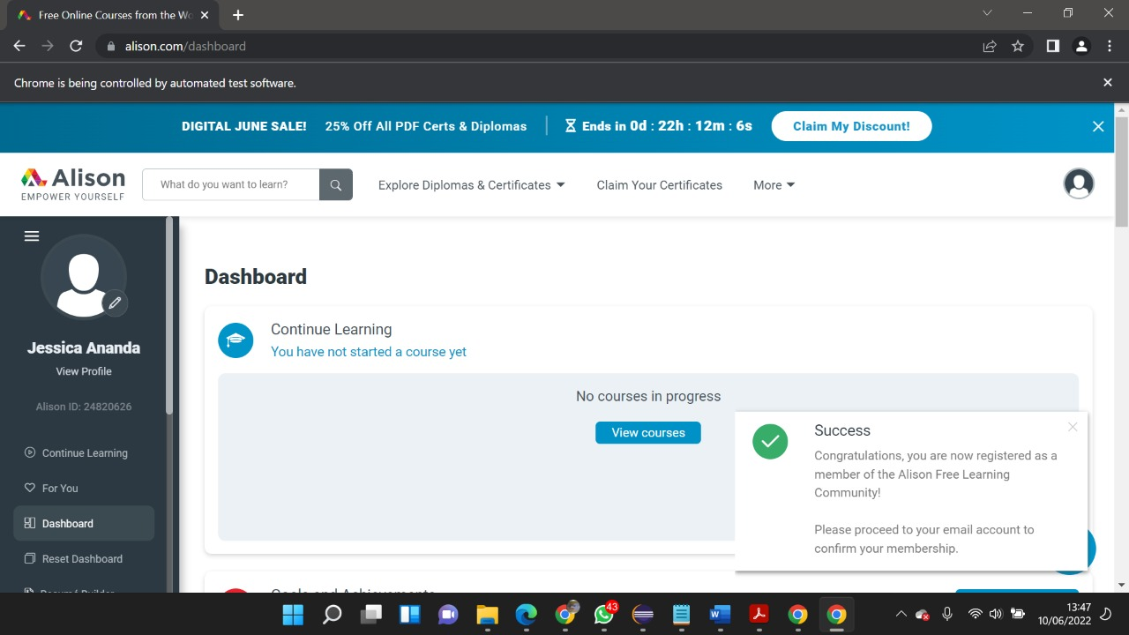

1. **Fungsi View Discover**
   1. Test Frame

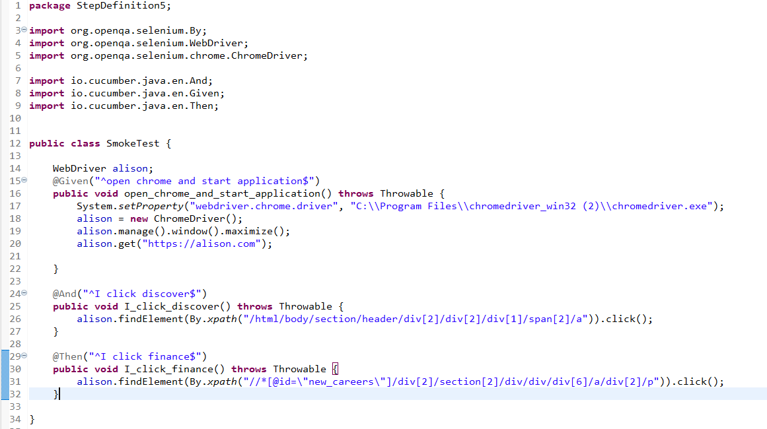

* 1. Scenario

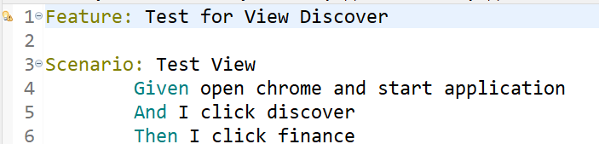

* 1. Test Runner

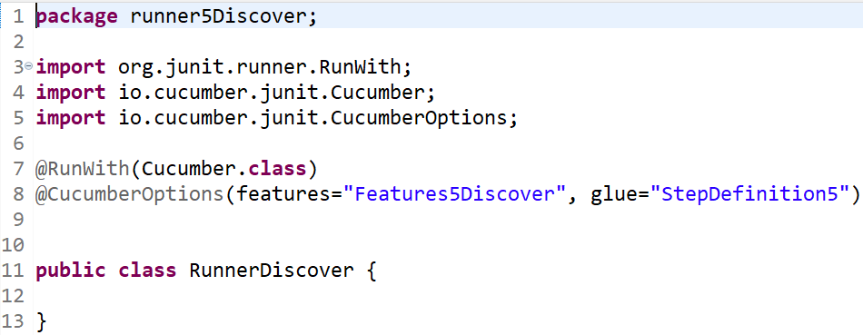

* 1. Console

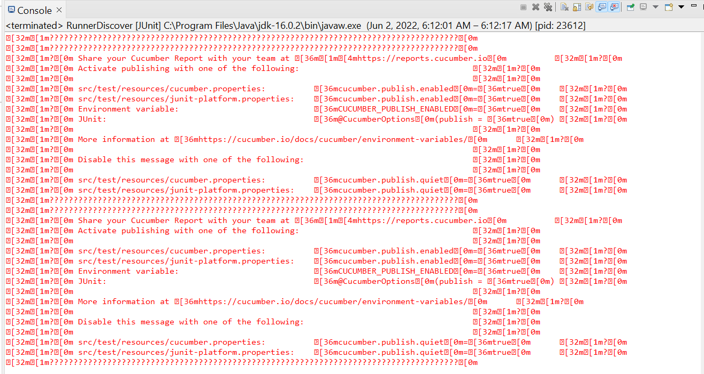

* 1. Browser

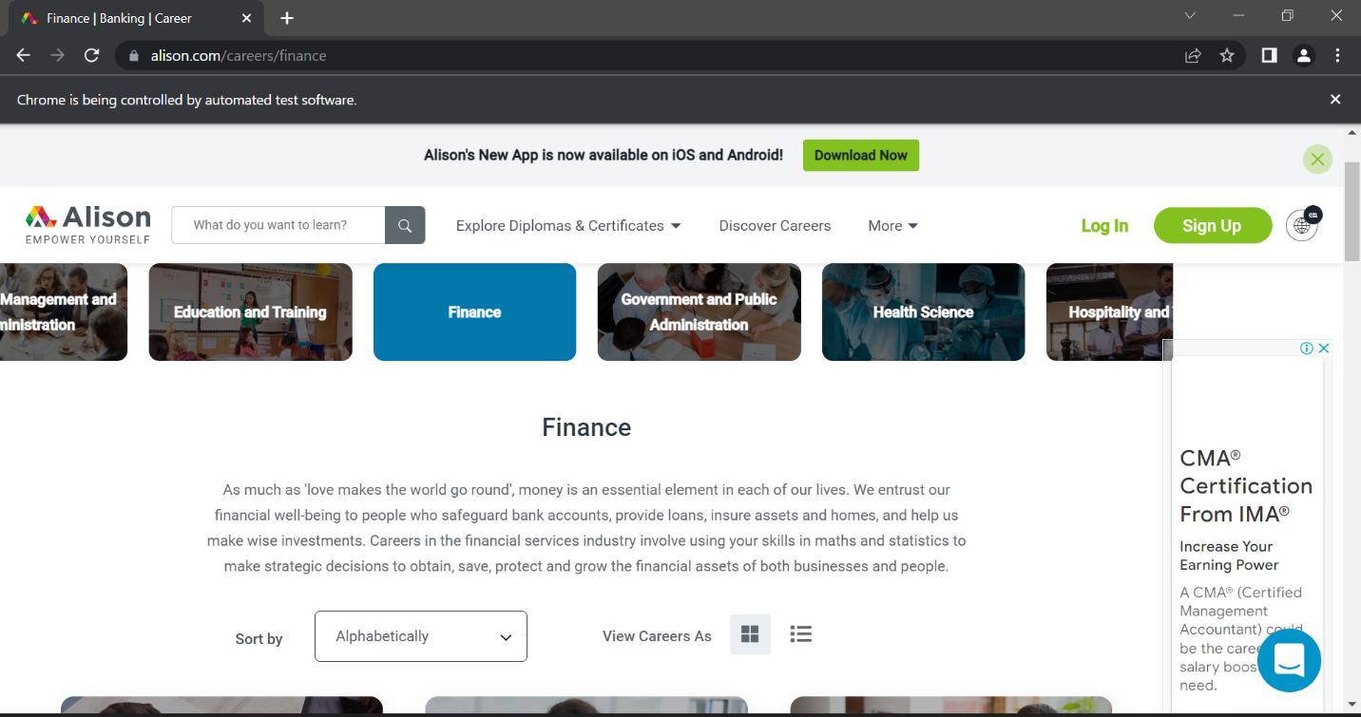

**Pengujian Aplikasi Alison Menggunakan Robot Framework**

1. **Fungsi Login**
   1. Scenario

|  |  |
| --- | --- |
| **Scenario** | **Description** |
| Open Browser | Alamat yang dituju adalah:  <https://www.alison.com/> |
| Click Element | User mengklik elemen *link* “Login” |
| Input Text | User memasukkan *username* pada *text field* |
| Input Text | User memasukkan password pada *text field* |
| Click Element | User mengklik *button* Login |

* 1. Test Frame

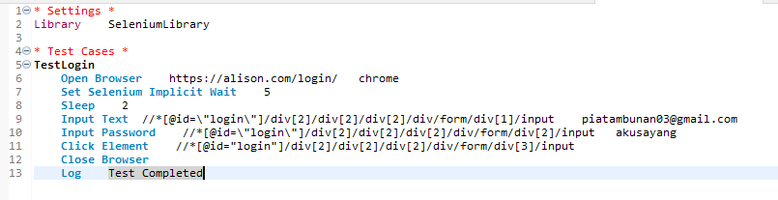

* 1. Console

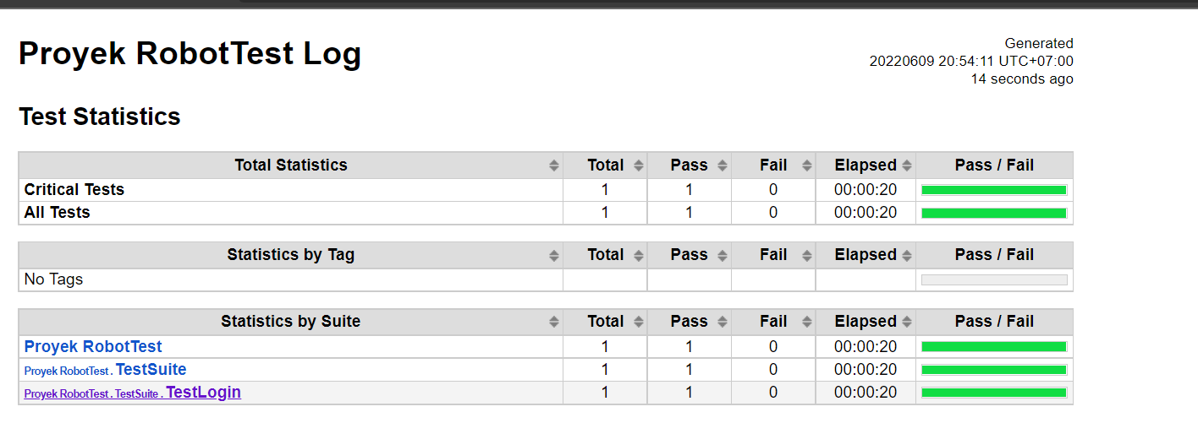

* 1. Browser

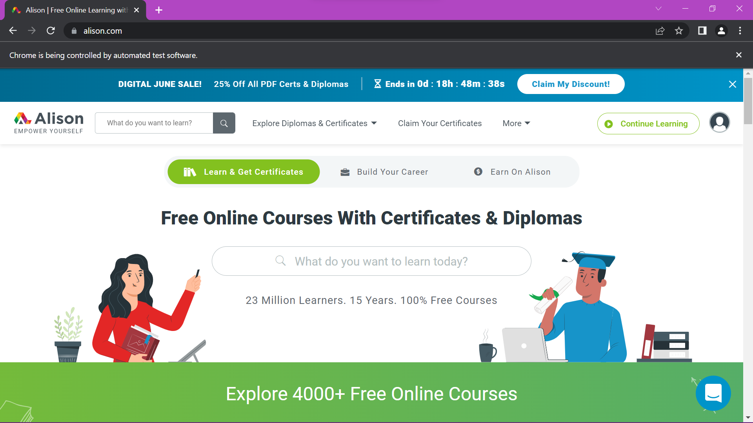

1. **Fungsi Search**
2. Scenario

|  |  |
| --- | --- |
| **Scenario** | **Description** |
| Open Browser | Alamat yang dituju adalah:  <https://www.alison.com/> |
| Click Element | User mengklik elemen *button “search”* |
| Input Text | User memasukkan datapada *text field* |
| Click Element | User mengklik *button* search |

1. Test Frame

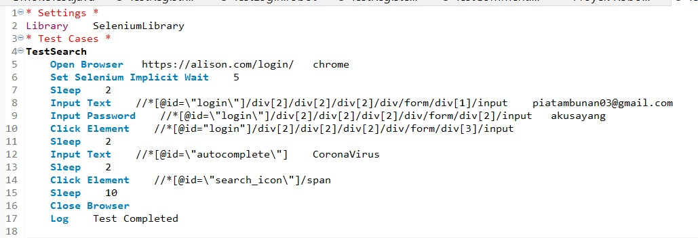

1. Console

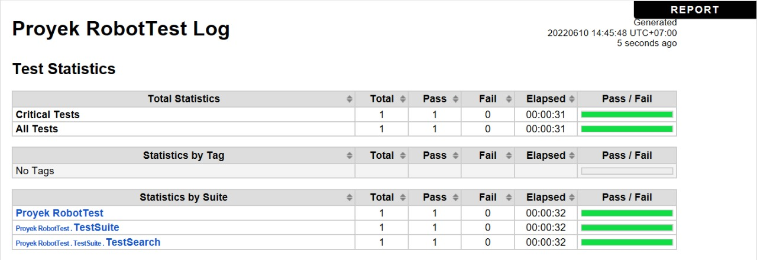

1. Browsers

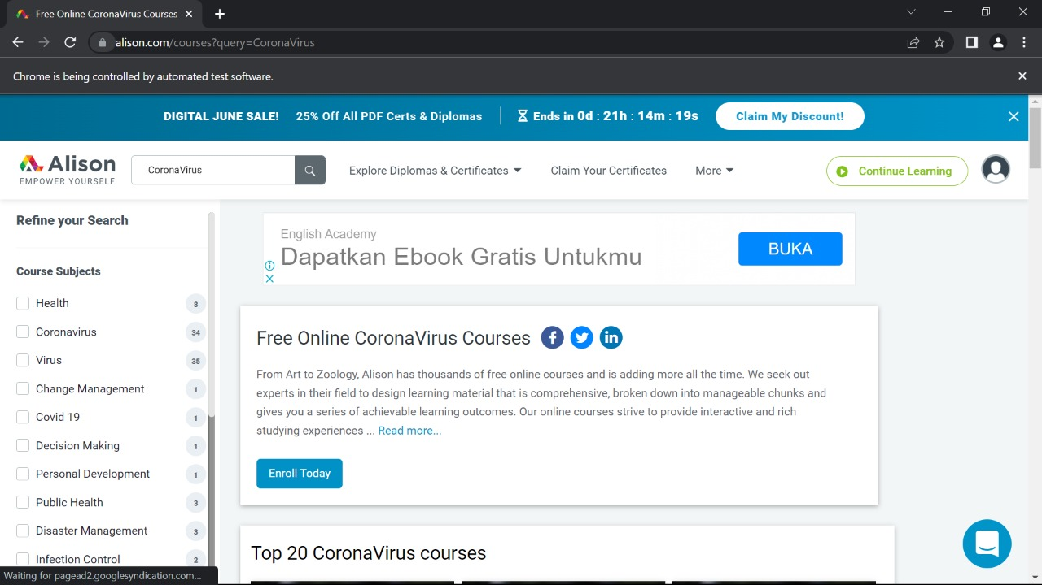

1. **Fungsi View**
2. Scenario

|  |  |
| --- | --- |
| **Scenario** | **Description** |
| Open Browser | Alamat yang dituju adalah:  <https://www.alison.com/> |
| Click Element | User mengklik elemen *button* “*Health*” |

1. Test Frame

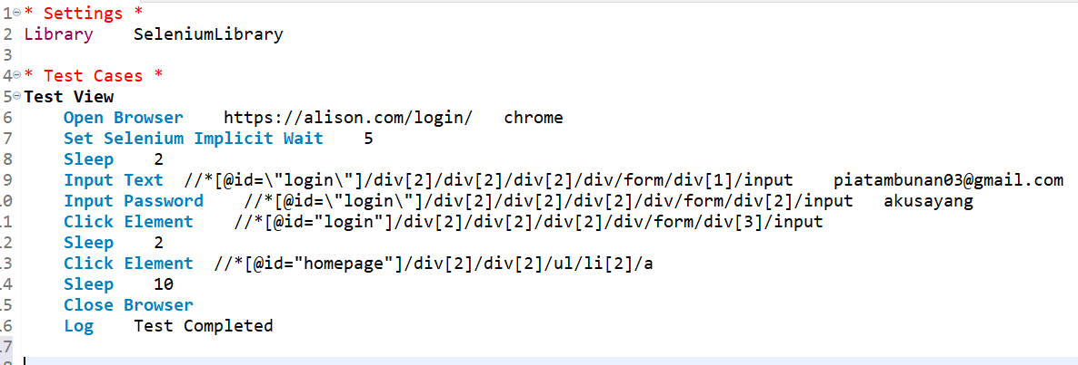

1. Console

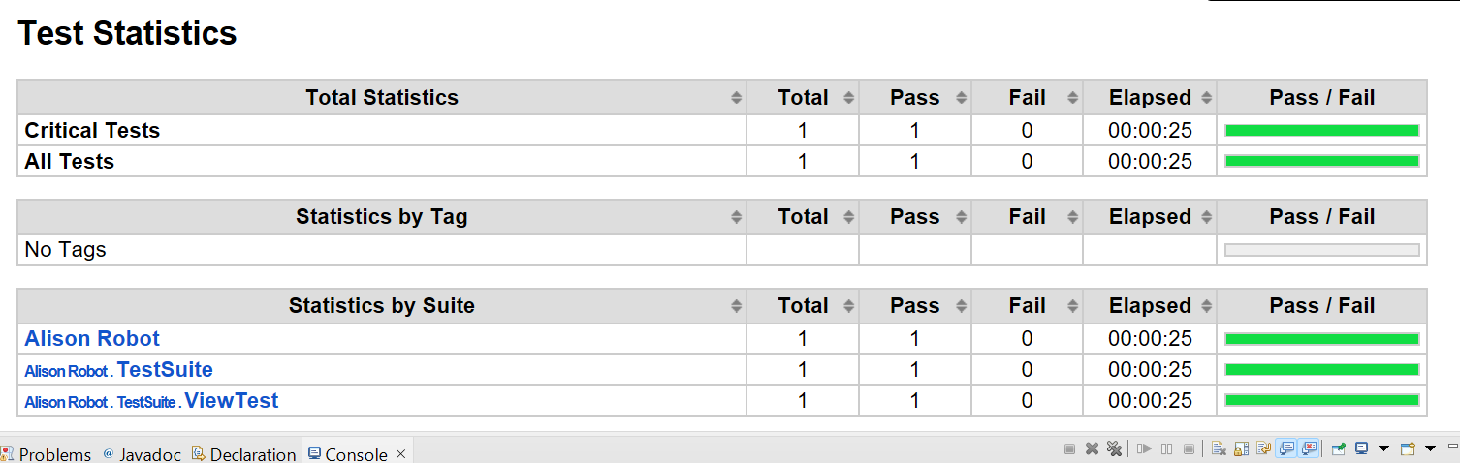

1. Browser

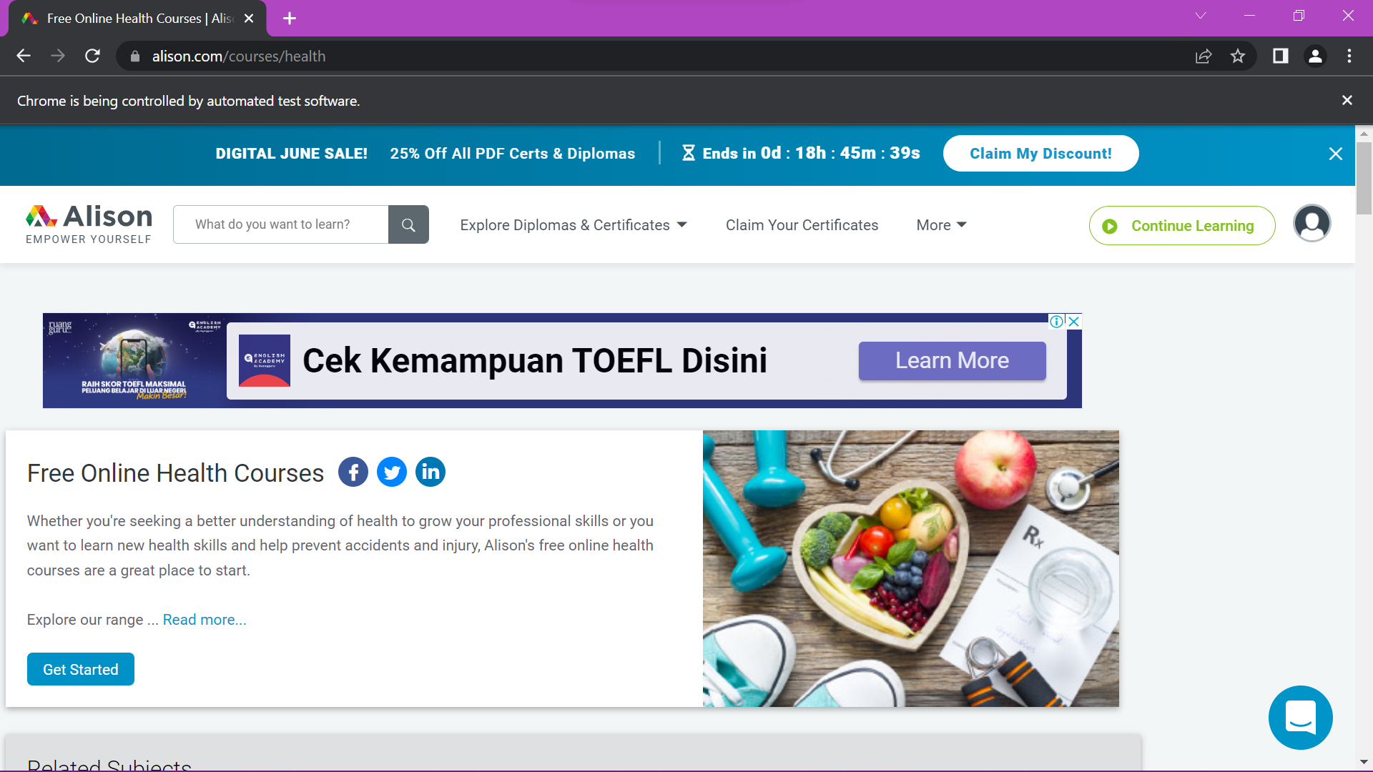

1. **Fungsi Forgot Password**
2. Scenario

|  |  |
| --- | --- |
| **Scenario** | **Description** |
| Open Browser | Alamat yang dituju adalah:  <https://www.alison.com/> |
| Click Element | User mengklik elemen *link* “Login” |
| Click Element | User mengklik elemen *link* “*Forgot Password*” |
| Input Text | User memasukkan *gmail* pada *text field* |
| Click Element | User mengklik *button “Reset My Password”* |

1. Test Frame

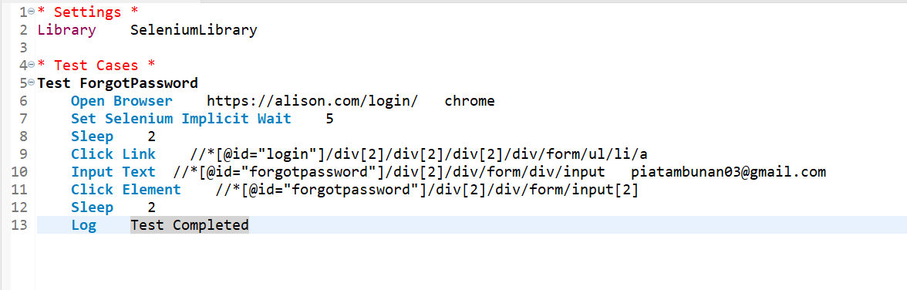

1. Console

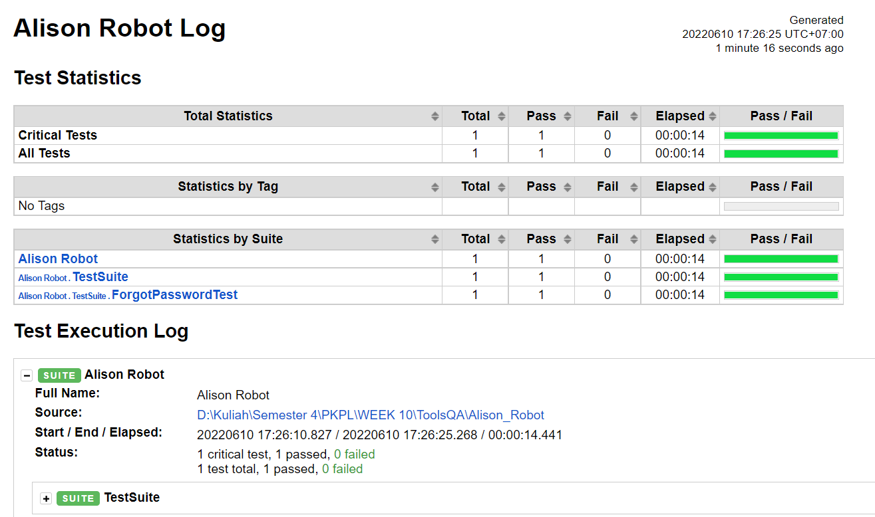

1. Browser

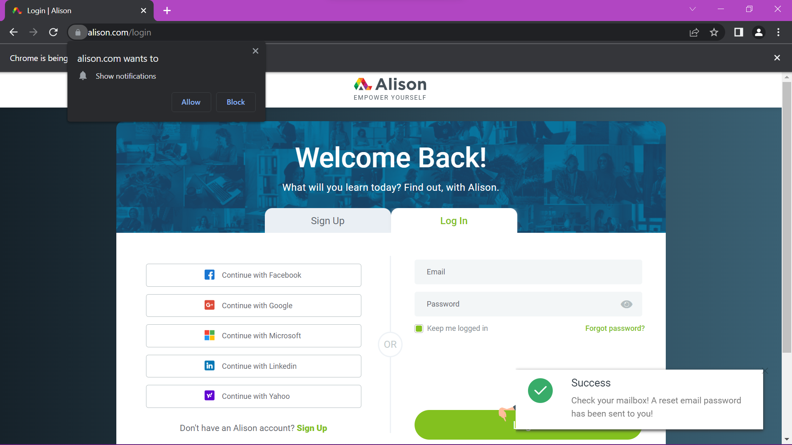

1. **Fungsi Search**
   1. Scenario

|  |  |
| --- | --- |
| * 1. **Scenario** | * 1. **Description** |
| * 1. Open Browser | * 1. Alamat yang dituju adalah:   2. <https://www.alison.com/> |
| * 1. Click Element | * 1. User mengklik elemen *button “search”* |
| * 1. Input Text | * 1. User memasukkan datapada *text field* |
| * 1. Click Element | * 1. User mengklik *button* search |

1. Test Frame

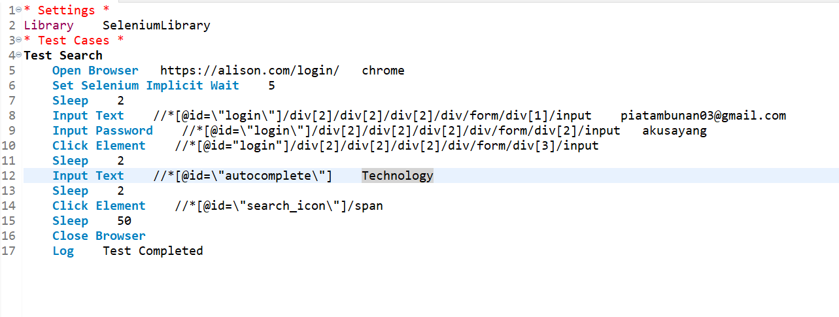

1. Console

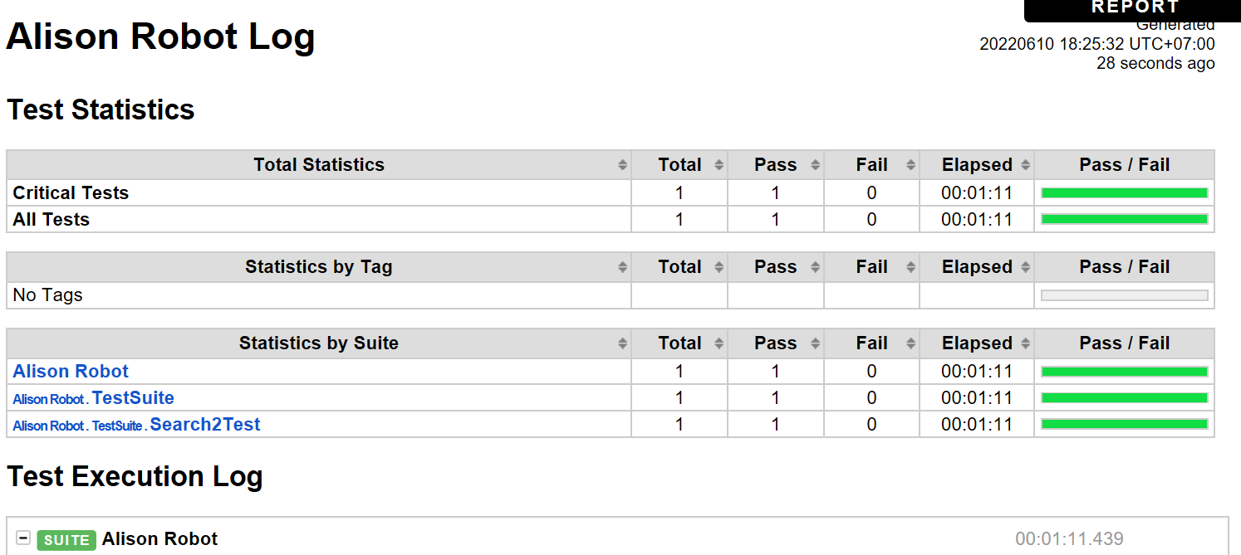

1. Browser

